Take Home Quiz

Question: Your goal is to investigate and identify the possible major reasons behind the lack of adequate homeowners’ insurance coverage. You are provided with a series of visualizations, and using a few or all of these, along with the information above, you are expected to connect the dots and uncover the underlying reasons.

My analysis starts with viewing the different visualizations given to us in the assignment. Specifically, I find that the Personal Income Across U.S. States chart is the most correlated for the question at hand. The chart below indicates that in the regions that require the lowest amount of insurance are also the regions that seem to have some of the lowest pay across the U.S. Unfortunately, the wages that are reflected in these regions are requiring homeowners that can afford home insurance at all to pay lower premiums for lower amounts of insurance. If wages were increased in these regions, then I would argue that higher premiums for higher coverage would become increasingly popular. Especially due to the recent natural disasters that have wreaked havoc in those areas. The people that can afford to purchase a home in these areas are having to deal with the income families need to produce to live comfortably, especially with real estate prices increasing as well. Furthermore, a graph that wasn’t shown in the analysis is one that I think is the most impactful: Real estate prices. “In fact, single-family house prices grew by **18.7%** from the first quarter of 2021 to the first quarter of 2022—the highest growth seen in at least 31 years.” (Ross, 2022) We are still feeling the effects of these increases, and the chart below highlights the same regions we are discussing with those home prices increasing. These rates have slowed down from that rapid increase during that period; however, with the lasting effects of those home prices and the charts that show the relative finances needed to live comfortably within the region coupled with the percentage of homeowners in those regions that live in their homes: 74.5% in West Virginia and 67.2% in Florida (Theiss, 2024). Overall, I think the fact that homeownership comes with benefits such as not needing to pay for home insurance is a big factor in this analysis as well. I know this fact from domain knowledge, since I used to own my own home. Due to the lack of compensation, increased home ownership, and real estate prices continuing to increase, I don’t think people can afford to or won’t elect to pay an additional expense for homeowners’ insurance since they have been “safe” statistically speaking in relation to natural disasters hitting these regions with severe damage. Moving forward, I think we will see a decrease or a plateau in home prices for these regions in the short term, or a massive increase in wages to support the necessity that is homeowners’ insurance due to the increase in storm damage that these regions are experiencing more often than they have in past years.

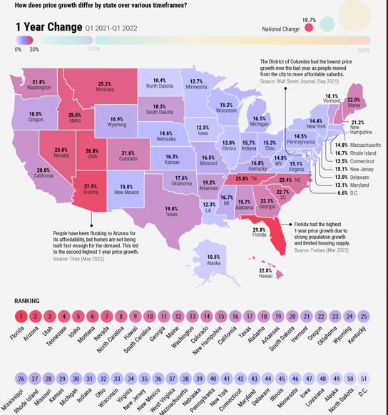

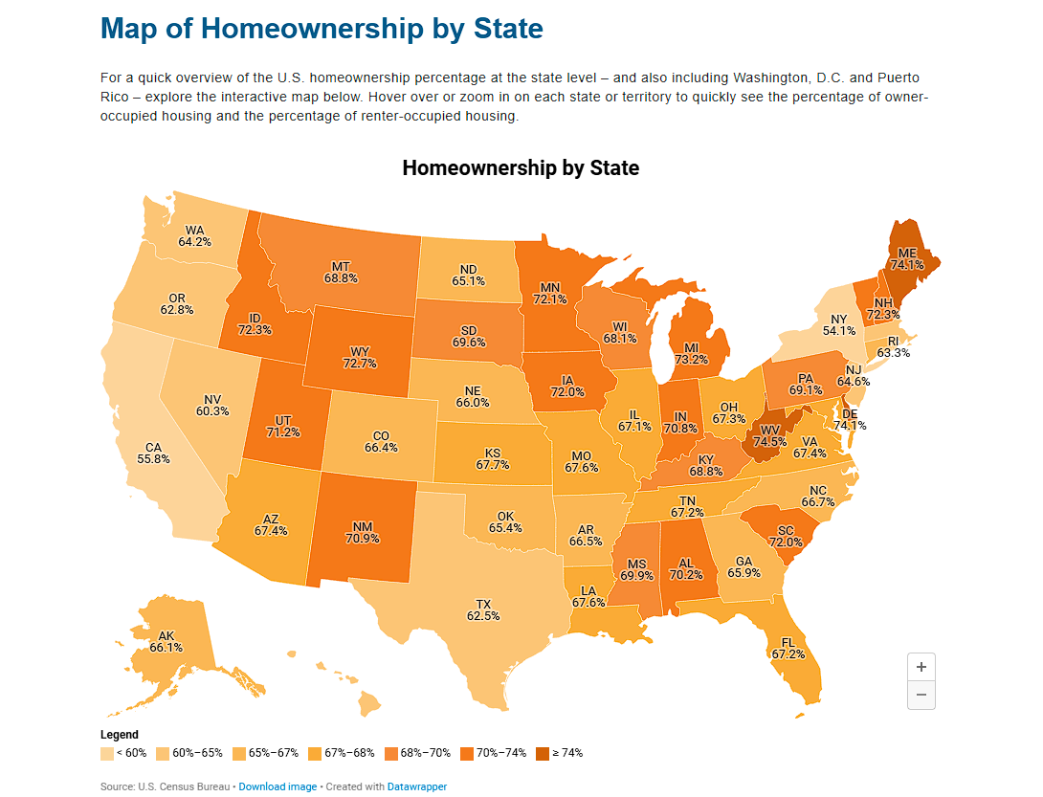

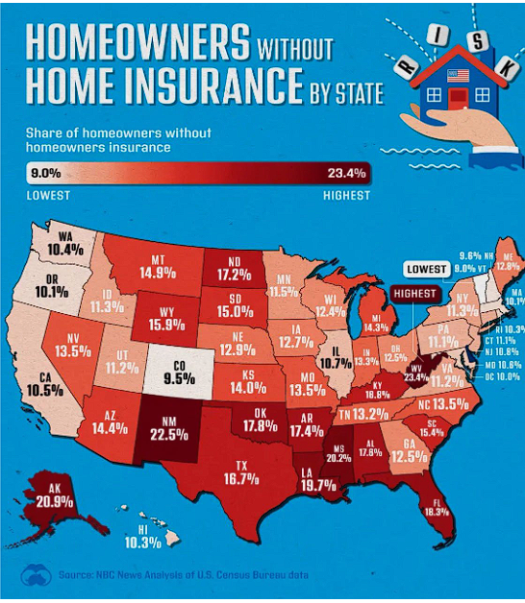

References:

Murphy, J., & Cui, J. (2024, September 17). *Map: New data shows how many Americans are going without homeowners insurance*. NBCNews.com. <https://www.nbcnews.com/data-graphics/map-new-data-shows-many-americans-are-without-homeowners-insurance-rcna169974>

Ross, J. (2022, October 17). *Mapped: The growth in U.S. house prices by State*. Advisor Channel. <https://advisor.visualcapitalist.com/growth-in-u-s-house-prices-by-state/>

Theiss, E. (2024, March 20). *Homeownership rates in the U.S. by state and City | PropertyShark*. 2024 Homeownership Rates in the U.S. by State and City. <https://www.propertyshark.com/info/us-homeownership-rates-by-state-and-city/>